Levels:
Global Economy
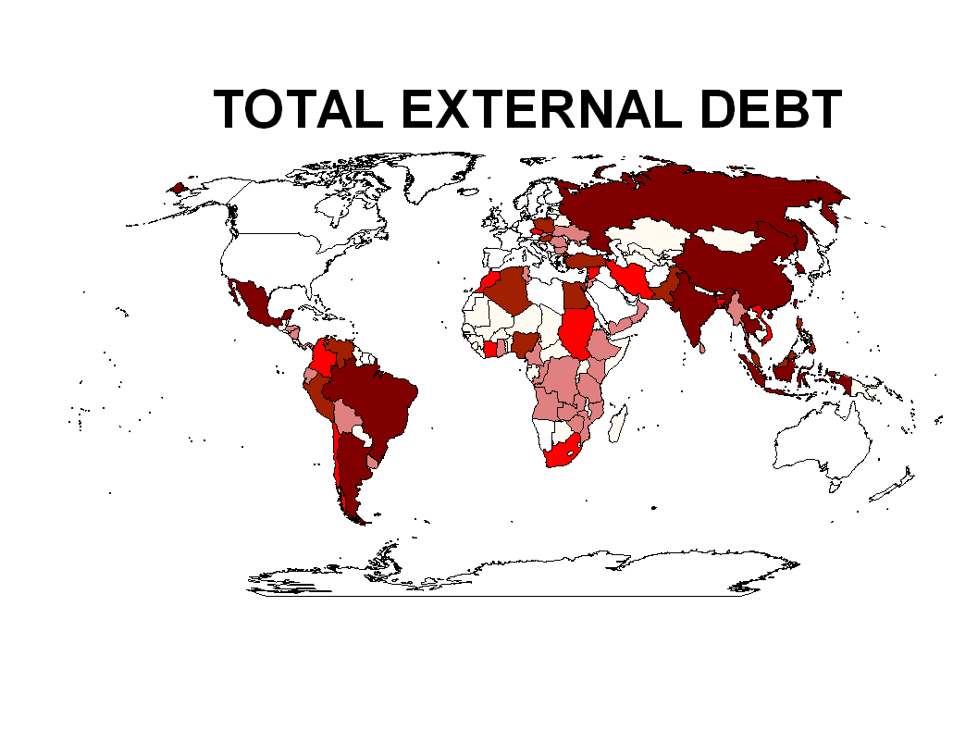
Grades 9 to 12

Subjects:
CDG3M, CGF3M, CGW4U, CGU4U, CGR4M, CGR4E

Process:
Through GIS processes,
Students investigate the current and changing nature of the global economy.

Objectives:
The student will:
1 Explore world the economy in relation to GDP, poverty, debt, investment and income equity.
2 Prepare maps showing GDP, poverty, debt, investment and income equity.
3 Analyze world poverty and external debt.
4 Use and query data tables linked and associated with maps.
5 Compute and use new data tables.
6 Display computed data using charts.
7 Prepare a map layout for printing.

Timeframe:
90 Minutes

Skills:
Knowledge/Understanding
Thinking/Inquiry
Communication
Application

Materials:
Computer system with ArcView GIS software

Vocabulary:
GDP, foreign investment, poverty, GINI index, development assistance,

Procedure:

- Students will research background information on the global economy.
- Students will download data sets needed for GIS analysis of the global economy (GDP, foreign investment, poverety, income equity, development assistance)
- Students will follow the defined GIS exercise to develop products that provide insight into the current and changing global economy.
- Students will use the GIS output products to answer questions that are inbedded into the exercise.

Homework Suggestion:

Reseach paper:
- Select an additional aspect of the economy. ( eg. Corporations, exports / imports, spending profiles etc.)
- Research the selected topic in order to develop a background paper and define a GIS project.
- Find, select and acquire data to be used in the GIS project.
- Produce GIS products to support the background paper.
- Define the implications for the global economy.

DISCUSSION

Knowledge/Understanding
- What is the global economy? Compare economic variables in several different countries (developed, developing, undeveloped).
- How can countries move towards a sustainable economy?
- Which countries show positive change and which countries show negative change? Why?
- How can the world move towards a sustainable economy?

Application
- Where do we see a sustainable economy in the real world?

Thinking/Inquiry
Start a discussion of the following:
- What do we need to know in order to measure the global economy?
- What is needed to improve the global economy (e.g. leadership, communication, trust, legislation, technology, trade, understanding of consequences, examples of failure, etc.)
- How does GIS analysis help to understand the complexity of the global economy?

